Title should be formatted using all capitals, font times new roman, size 11, bold, centered

Eduard Petrovský1, Igor Tunyi2

1 Geophysical Institute Acad. Sci. Czech Republic, Boční II/1401, 141 31 Prague 4, Czech Republic (edp@ig.cas.cz)
2 Geophysical Institute, Slovak Academy of Sciences, Dúbravská cesta 9, 845 28 Bratislava, Slovakia (geoftuny@savba.sk)

In case of plain text, with neither figures, nor tables, 1 A4 page abstract will be accepted. Title should be prepared in MS Word, using formats as follows:
Font to be used is Times New Roman. Size of the font is 10 pts, for sub- and superscripts use size 8 pts. and lowered (raised) by 3 pts. Title should be in bold, all capitals, centered, and 11 pts. Authors should be centered, formatted with 9 pts. and “small caps”. First name should be placed first. Before and after list of authors, leave 1 blank line. Affiliations should be formatted using 9 pts., left aligned. In case of more authors, number the affiliations respectively. In this case, leave 3 pts empty space after each affiliation, and each of them should be with hanging indent of 0.5 cm. Leave 2 blank lines after the block of affiliations.
Text of the Abstract should be justified, with first line indented by 0.5 cm. In case of mathematics, ask for more detailed instructions. 1-page Abstract should not be structured in Sections. Leave 1 blank line between the text of abstract and References.
Figures and Tables (max. 3 objects in total) should be centered, placed in-text at their respective positions. Captions should be written following the examples given here (Fig. 1 and Table 1). Only B&W figures will be printed. All the objects must be referred to in the text. Text of the Abstract should not flow around the Figures or tables. In case of smaller, or more simple figures, two figures can be placed next to each other. If possible, use Frames to position the figures and tables on the page.
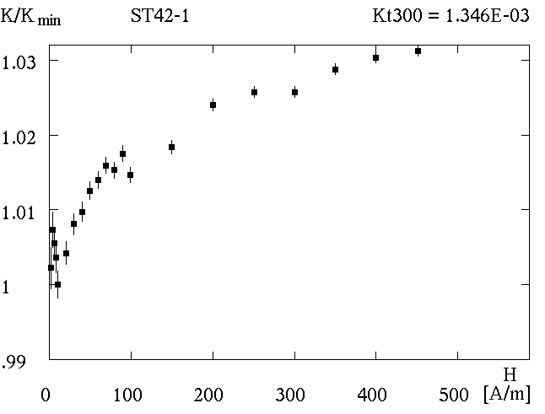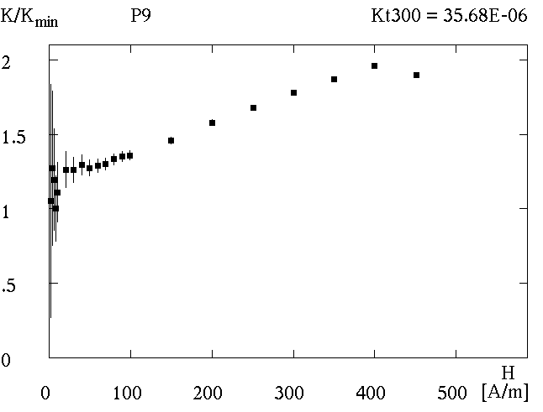
Fig. 1. Role of error bars in the interpretation of susceptibility vs. field curves. Data measured by the KLY-4S Kappabridge. a) Example of specimen with mostly short error bars. The susceptibility changes with field can be interpreted as real susceptibility variation with field, b) Example of specimen with mostly short error bars at high fields and large bars at low fields. The susceptibility changes at low fields should be interpreted rather as measuring errors than as real susceptibility variation with field.
a)
b)
References in the text should include the names of the authors (without initials), followed by the publication year in parentheses. The whole reference should be in italics. If there are more than two authors, only the first author’s name should be given in the reference, followed by “et al.” (for example: “ ... as shown by Brown (1991) ...”, “... discussed in Smith et al. (1995) and Scott and Jackson (1996) ...”, “... as proved earlier (Black, 1994; Miller and Mayer, 1992, 1993)”.) As regards the list of references, please, follow the rules of Studia Geophysica et Geodaetica (available at http://springerlink.metapress.com/link.asp?id=109194). Examples of references are also given below.

References
Table 1. Total susceptibilitites of the test specimens measured by the KLY-4S Kappabridge. The data for individual field intensities represent the mean values calculated from 10 measurements of the complete susceptibility vs. field curves. As the specimens have volumes equaling the nominal volume, the total susceptibilities equal the bulk ones.
H  [A/m] | M1  [E−6] | M2  [E−6] | M3  [E−6] | M4  [E−6] | M5  [E−3] | M6  [E−3] | M7  [E−3] | M8  [E−3]
2 | 8.68 | 44.68 | 85.25 | 509.6 | 1.090 | 5.267 | 9.851 | 50.65
4 | 10.05 | 53.01 | 95.90 | 508.2 | 1.097 | 5.233 | 9.785 | 50.29
6 | 8.59 | 46.80 | 95.90 | 504.1 | 1.085 | 5.212 | 9.756 | 50.14
8 | 10.82 | 50.09 | 94.75 | 504.3 | 1.085 | 5.204 | 9.742 | 50.07
10 | 9.82 | 50.27 | 95.62 | 502.1 | 1.079 | 5.167 | 9.700 | 49.70

Nawrocki J., Bakhmutov V., Bogucki A. and Dolecki L., 1999. The palaeo- and petromagnetic record in the Polish and Ukrainian loess-palaeosol sequences. Phys. Chem. Earth (A), 24, 773−777.
Dunlop D. and Özdemir Ö., 1997. Rock Magnetism. Fundamentals and Frontiers. Cambridge University Press, Cambridge, U.K.
Evlogiev J., 1993. Paleogeography and stratigraphy of the Early Pleistocene in near Danube Northeastern Bulgaria. PhD Thesis, Bulg. Acad. Sci., Sofia, Bulgaria (in Bulgarian).
Hrouda F., Chlupáčová M. and Mrázová Š., 2006. Low-field variation of magnetic susceptibility as a tool for magnetic mineralogy of rocks. Phys. Earth Planet. Inter., in print.
Chlupáčová M., 1984. Anisotropy of magnetic susceptibility. In: M. Chlupáčová, P. Pruner, M. Krsová, F. Hrouda and V. Jelínek (Eds.), Magnetic Properties of Rocks and Ores with Pyrrhotite. Geofyzika, Brno, Czech Republic, 76−106 (in Czech).

